Electric Circuits & Electronics Design Lab

EE 316-01

# Final: (Lab12) Amplification with MOSFETs

By: Jaiden Gann

Lab Section 316-01

Lab Date: 7/27/22

Lab Due: 7/29/22

## Introduction:

For the final lab, I did the amplification with MOSFETs. There will be three sections: theoretical that gives some background on MOSFETS, experimental, and results and conclusion. The data gathered in lab along with pictures of the circuits will be provided in the Appendix.

## Theoretical Analysis:

To start, we look at how a MOSFET is constructed, works, behaves depending on the state or mode it is in. The MOSFET is a three terminal unipolar semiconductor that is a voltage-controlled field effect transistor. The main gate is isolated from the current carrying channel and no current flows into the gate. They operate in two modes: depletion which requires the gate source voltage to switch off and enhancement which requires a gate source voltage to switch the device on. Figures 1 and 2 gives the characteristic curves for an n-channel MOSFET and p-channel MOSFET in depletion (a) and enhancement mode (b).

**Figure 1**. Characteristics of N-Channel MOSFET

**Figure 2.** Characteristics of P-Channel MOSFET

## Experimental:

For this part of the lab, we created the circuit in Figure 3 on a physical board and observed the output given a certain frequency. The gain versus frequency was plotted so we could observe the bandwidth of the MOSFET. The lowest frequency that would give a result was 30 Hz. The bandwidth is shown by the green line. Table 1 is the data collected and Figure 4 is the plot of gain versus frequency.

**Figure 3**. Amplification circuit with MOSFET

**Table 1.** Amplification observations

|  |  |  |
| --- | --- | --- |
| F(HZ) | VOUT (mV) | Gain(db) |
| 20 | 580 | 7.921441451 |
| 30 | 800 | 10.71468132 |
| 60 | 920 | 11.92863813 |
| 100 | 1.01 v | 12.73930906 |
| 200 | 1.05 v | 13.07666756 |
| 500 | 1.05 v | 12.92881906 |
| 1000 | 1.05 v | 12.92881906 |
| 2000 | 1.05 v | 12.92881906 |
| 5000 | 1.03 v | 12.76177757 |
| 10000 | 980 | 12.32955459 |
| 15000 | 940 | 11.96759015 |
| 20000 | 880 | 11.39468652 |
| 50000 | 580 | 7.62821902 |
| 75000 | 420 | 4.824644956 |
| 100000 | 340 | 2.989237489 |
| 150000 | 240 | -0.03611602 |
| 200000 | 200 | -1.61974094 |
| 500000 | 100 | -7.64034085 |
| 750000 | 80 | -9.57854111 |
| 1000000 | 60 | -12.0773158 |
| 1500000 | 60 | -12.0773158 |

**Figure 4.** Gain vs Frequency

## Results and Discussion:

The bandwidth is anywhere the gain is greater than 9. Compared to the previous results gathered for Lab 12 and in the simulation portion of that lab, the plot follows the same trend we say. Its also around the same gain as the simulation results. There are more points on the right side of the plot because the MOSFET starts out already being really close to the bandwidth which makes more points on the other side be lower.

Once again the oscilloscope was doing weird things. The auto scale would always default the output to around 400 mV after 1M Hz. The output gathered also seemed to be very high, however, this is not the first time the oscilloscope has given an output that is higher than it should be but still followed the correct trend.

Figure 5 is an example of the output waveform at 300 Hz and Figure 6 is the waveform at 3M Hz before pressing auto scale and Figure 7 is after pressing auto scale.

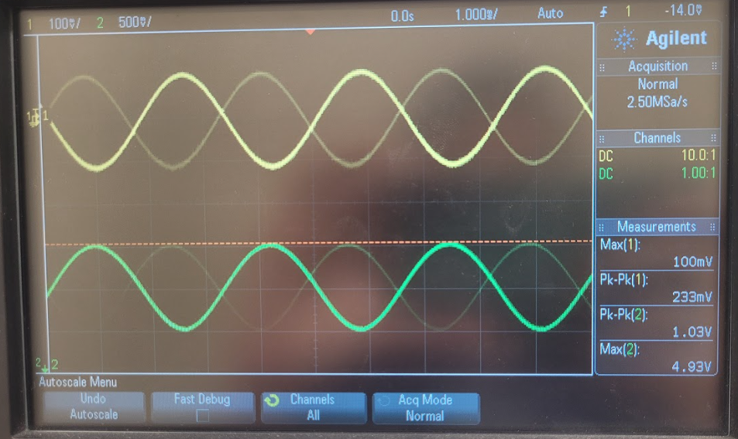

**Figure 5**. Waveform at 300 Hz

**Figure 6.** 3M Hz No Auto Scale

**Figure** 7.3M Hz Auto Scale

## Conclusion

Overall, the results of lab matched pretty well with the simulation done earlier as far as the plot. The data itself in comparison to the simulation was higher but the highest gain was only 1 more than what was observed in simulation. In comparison to the last time the experimental part was done, the data itself is very different from the previous data collected but the plot is similar.

## Appendix 1:

N/A

## Appendix 2:

Signed lab results

Pictures of Circuits

**Figure 1**. Characteristic Circuit (ref Figure 3)